Regeneration potential of the Schmidtea mediterranea CIW4 planarian.

Jaba Tkemaladze¹, Mariam Kipshidze²
¹Free University of Tbilisi, 240 David Aghmashenebeli Alley, 0159, Tbilisi, Georgia.
²Tbilisi State Medical University, Tbilisi, Georgia

Abstract
Fully developed multicellular organisms constantly regenerate, replacing old cells with new ones derived from stem cells through asymmetrical division. Despite the theory suggesting an immortal pool of stem cells, their quantity diminishes over time, contributing to the ageing process. During asymmetric stem cell division, old centrioles are preserved in daughter stem cells. Unlike nuclear DNA, centrioles lack the ability for reparations. Old centrioles are more prone to decay, potentially making them the primary agents of cellular ageing. Based on the assumption, acentriolar stem cells likely resist cellular ageing. To test the hypothesis, Schmidtea mediterranea CIW4, lacking centrioles in their stem cells, were incised at various intervals from regeneration to demise. Tails, with more acentriolar stem cells than heads, exhibited a higher regeneration rate at a 76:42 ratio.

Keywords: neoblast; planarian; regeneration; ageing; senescence; stem cells

Introduction
Attempts to preserve the quality of life in older people are the main goal of modern medicine. In living organisms, anti-entropy processes always and everywhere occur: the replacement of old (high-entropy) structures with new (low-entropy) structures. Where and when replacement with new structures is unprofitable, they are repaired to reduce entropy. Repair occurs everywhere and always, except for the centrioles.

Mother centrioles are not repaired. Moreover, during the asymmetric division of adult stem cells, it is precisely these maternal (high-entropy) centrioles that are inherited by daughter cells that retain the potential (cytogenetic status) of the mother cell. This paradoxical event, which is a bright spot in the fight against entropy in a living organism, has so far been explained by only one hypothesis: the biological essence of this event is that centrioles carry and distribute differentiation inducers (Tkemaladze, 2005).

According to this hypothesis, the structure of differentiation inducers is associated with centrioles and the absence of centrioles means the cell is totipotent. As is known, planarian cells do not have centrioles, both in neoblasts and in differentiated-born cells. With a simple experiment, it is possible to test an alternative mechanism to the centriolar inheritance of structures that induce differentiation from the mother cell to the daughter cell (Tkemaladze, 2023).

Materials and methods
All the multicellular animal somatic cells known to science have centrioles. During meiotic divisions, the centrioles get eliminated and high morphogenetic status disappears. Following ovum fertilization, centrioles are created de novo with a set zero morphogenetic status.

There are, however, some exceptions in the animal kingdom. Similar to acentriolar totipotent plant cells, mature pluripotent cells (neoblasts) of planarians do not have centrioles (Azimzadeh, 2012). Similar to plants, planarians are able to regenerate a whole organism from a little body fragment (Scimone, 2014). To exclude the death of neoblasts due to chromosomal instability caused by telomere shortening, the asexual planarian strain, Schmidtea mediterranea, was chosen for the experiment.

As the telomere length of the neoblasts of the strain in question is easily restored after 7-day starvation (Iglesias, 2019).
Planarians cultures
The asexual strain of 6-8 mm planarians Schmidtea mediterranea CIW4 was selected and subjected to starvation for a week prior to the experiment. The planarian cultures were maintained in conditions described in Newmark’s experiment (Newmark, 2000). In dark incubators with a temperature of 21 °C, and were exposed only to diffused light during the feeding times on beef liver and in the acts of incision of their heads and tails for not longer than 1 hour. Immediately after each feeding, planarians were transferred with the help of a pipette to clean sample wells containing pure cultural water.

Neoblasts in planarians are distributed in clusters along the midline and bilateral lines in the dorsal mesenchyme, hence their dense presence can be expected in the tail region where all the lines converge (Orii, 2005). Therefore, to have more neoblasts and fewer of their descendants, especially those with centrioles, one millimetre of the tail was transversely incised; and to have fewer neoblasts and more highly differentiated cells the head part below the eye level was transversely incised (Fincher, 2018). The incision of these two different parts of the planarian body is necessary to examine and compare regenerative potential and ageing rate in the different parts of the organism.

Results

Head Lines (HL) experiment
With the aim of establishing how long incised heads can regenerate into a whole organism, every 4 weeks heads of 72 planarians were incised and put in separate wells of Petri dishes; their amputated parts below eye level were discarded. The HL experiment lasted from 30th October 2016 to January 2020. The first planarian of the HL died before its 3rd tail amputation. Subsequently, planarians of HL died gradually until January 2020. Maximum regeneration number after incisions of the head fragment of the last planarian has reached 42

Tail Lines from Head Lines after the 3rd head incision (TLfHL) experiment
With the aim of establishing how long incised tails can regenerate into a whole organism – if a planarian was obtained as a result of regeneration after 3rd head incision. Every 4 weeks, the tails of such 71 planarians were incised and put in separate wells of Petri dishes; their amputated heads were discarded. The TLfHL experiment lasted from 19 February 2017 to May 2021. The first planarian of this experiment died before the first incision of the tails. The last planarian of TLfHL died before May 2021. Maximum regeneration number after tail incisions of the last planarian has reached 54.

Tail lines (TL) experiment
With the aim of establishing how long incised tails can regenerate into a whole organism, every 4 weeks the tails of 72 planarians were incised and put in separate wells of Petri dishes; their amputated heads were discarded. The TL experiment lasted from 30th October 2016 to September 2022. The first planarian of the TL died before its 4th head amputation. Subsequently, planarians of TL died gradually until September 2022. Maximum regeneration number after incisions of the tail of the last planarian has reached 76. The rate of death of these three lines is demonstrated in the diagram below.

Discussion
The research of long-term differences of regeneration fragments from the head and from the tail requires distinguishing separate HL and TL. Planarians’ survival ability from HL and TL generates facts about organism ageing of planarians of these lines. Quantity patterns of possible regenerations before death represent youth measurement of organisms in S. mediterranea, whereas reduction of regenerations is characteristic of the ageing of planarians. Thus, ageing can be determined quantitatively: if regeneration fragments from incised fragments decrease, it points to the reduction of vitality and regenerative capacities.

It is logical to assume that ageing signs manifest faster in large planarians that are in the prime of their physiological capacity, therefore large planarians of 6 mm and more were chosen for the experiment.

The vitality of each line has declined, though at different rates. TL has demonstrated uncommon survivability, obviously, characteristic of germ lines. Similar survivability, though slightly less, was detected in TLfHL. Assuming, the asymmetrical division of an original planarian must play a key role in the differences between head and tail ageing. Incised tail (1 mm) in comparison to incised head (2-3 mm) is smaller in its measure, but highly differentiated cells are absent in the tail area.

The quantity of neoblasts is scarce in the head fragment. Highly differentiated cells and organs out of these highly differentiated cells are preserved, therefore regeneration of most organs of the head fragment is unnecessary. As for the tail, it must regenerate new differentiated structures from pluripotent populations of neoblasts.
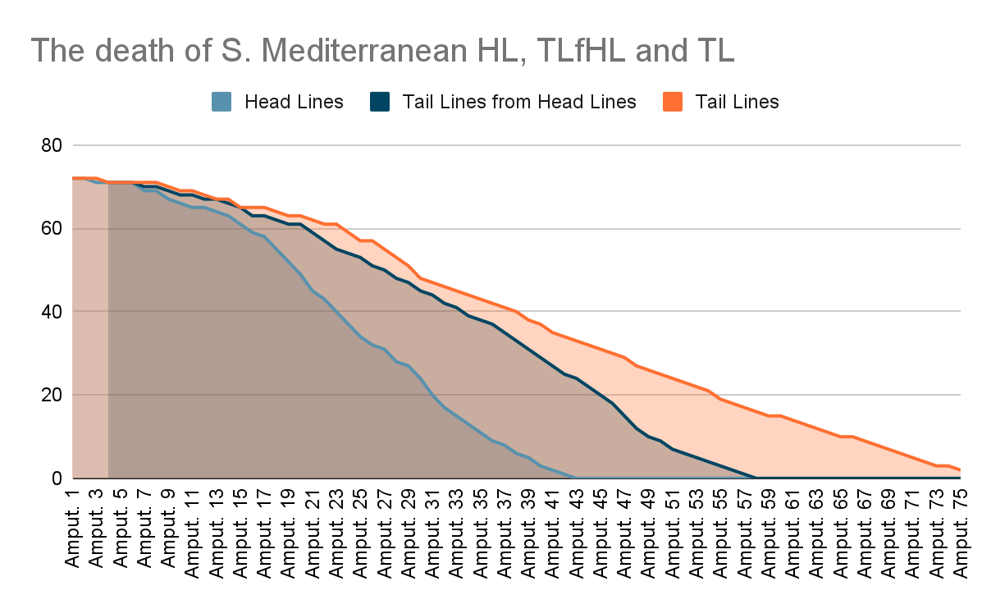

Conclusion
Intensive regeneration, the revulsion of death, takes place in individuals of TL; the same activity was detected in TLfTL, though slightly less. These findings are sufficient to conclude that regardless of the origin (whether the planarian has developed from TL or TLfHL) ageing in planarians regenerated from the tail fragment is slower than in planarians regenerated from the head fragment. It indicates that preserving regeneration potency depends on acentriolar neoblasts and the density of their population.

References:

- Azimzadeh J, Wong ML, Downhour DM, Sánchez Alvarado A, Marshall WF. Centrosome loss in the evolution of planarians. Science. 2012 Jan 27;335(6067):461-3. doi: 10.1126/science.1214457. Epub 2012 Jan 5. PMID: 22223737; PMCID: PMC3347778.
- Fincher CT, Wurtzel O, de Hoog T, Kravarik KM, Reddien PW. Cell type transcriptome atlas for the planarian Schmidtea mediterranea. Science. 2018 May 25;360(6391):eaaq1736. doi: 10.1126/science.aaq1736. Epub 2018 Apr 19. PMID: 29674431; PMCID: PMC6563842.
- Iglesias M, Felix DA, Gutiérrez-Gutiérrez Ó, De Miguel-Bonet MDM, Sahu S, Fernández-Varas B, Perona R, Aboobaker AA, Flores I, González-Estévez C. Downregulation of mTOR Signaling Increases Stem Cell Population Telomere Length during Starvation of Immortal Planarians. Stem Cell Reports. 2019 Aug 13;13(2):405-418. doi: 10.1016/j.stemcr.2019.06.005. Epub 2019 Jul 25. PMID: 31353226; PMCID: PMC6700675.
- Newmark PA, Sánchez Alvarado A. Bromodeoxyuridine specifically labels the regenerative stem cells of planarians. Dev Biol. 2000 Apr 15;220(2):142-53. doi: 10.1006/dbio.2000.9645. PMID: 10753506.
- Orii H, Sakurai T, Watanabe K. Distribution of the stem cells (neoblasts) in the planarian Dugesia japonica. Dev Genes Evol. 2005 Mar;215(3):143-57. doi: 10.1007/s00427-004-0460-y. Epub 2005 Jan 19. PMID: 15657737.
- Scimone ML, Kravarik KM, Lapan SW, Reddien PW. Neoblast specialization in regeneration of the planarian Schmidtea mediterranea. Stem Cell Reports. 2014 Aug 12;3(2):339-52. doi: 10.1016/j.stemcr.2014.06.001. Epub 2014 Jul 4. PMID: 25254346; PMCID: PMC4176530.
- Tkemaladze J. Reduction, proliferation, and differentiation defects of stem cells over time: a consequence of selective accumulation of old centrioles in the stem cells? Mol Biol Rep. 2023 Mar;50(3):2751-2761. doi: 10.1007/s11033-022-08203-5. Epub 2022 Dec 30. PMID: 36583780.
- Tkemaladze J, Chichinadze K. Potential role of centrioles in determining the morphogenetic status of animal somatic cells. Cell Biol Int. 2005 May;29(5):370-4. doi: 10.1016/j.cellbi.2005.03.003. PMID: 15886028.
- Chichinadze K, Lazarashvili A, Tkemaladze J. RNA in centrosomes: structure and possible functions. Protoplasma. 2013 Feb;250(1):397-405. doi: 10.1007/s00709-012-0422-6. Epub 2012 Jun 10. PMID: 22684578.

